**Aditi Ponemone | Portfolio**  
📧 aditi.ponemone@mail.utoronto.ca | [LinkedIn](www.linkedin.com/in/aditi-ponemone-418608293)

**🔹 Featured Projects**

1. **Product Designer |** *ESP Project – Wearable Watch for Autism/ADHD* **January – April 2023**🚀

🚀 **Goal:** Develop a wearable watch designed to support children with Autism/ADHD by enhancing focus, engagement, and daily task management. The project combined UI/UX design, CAD modeling, and accessibility-driven product development.

🔧 **Tools:** Figma, Fusion 360, 3D Printing, UX Research

📌 **Key Highlights:**  
• Led the UI/UX design and CAD modeling for a wearable watch tailored for neurodivergent children.  
• Conducted client interviews and user research to understand the unique needs of children with Autism/ADHD.  
• Designed high-fidelity Figma prototypes for the watch’s companion mobile app, ensuring accessibility and intuitive navigation.  
• Developed 3D models and 3D-printed prototypes, incorporating a physical activity timer and reward system.  
• Integrated haptic feedback and visual cues to enhance engagement and usability for children.

**Table 1. Primary and Secondary Functions**

| **Primary Function** | **Secondary Functions** |
| --- | --- |
| The design prompts User to participate in gym class. | Provides motivating stimuli that encourages desired behaviour.  Examples include tangible items, time breaks, and reward systems |
| Administers motivation, physically or virtually. |
| Reduces aversive environmental factors.  Factors include:   * Physical activities unsuitable for the user’s motor ability. * Unexpected activity changes. * Lack of interest or concise instructions. * Sensory overload. |
| Generates personalized instructions. |
| Affords choice in activity type and level. |

**Objectives**

The objectives (Table 2) were determined through benchmarking a mobile device, as it contains a mix of both software and hardware - allowing exploration of the problem space considering both features.

**Table 2: Objectives and Metrics**

| **Objectives** | **Metric** | **Objective Goal** |
| --- | --- | --- |
| Usability. | Time required for User to learn how to use the device | - Less than 4 weeks |
| Conditions environmental factors. | Number of aversive environmental factors reduced | - Minimum 1  The preference test primarily mentions aversion to activity and physical pain |
| Portability during physical activity and stationary use. | Dimensions | Size  < 7cm x 15.7cm x 3cm  Average size of a mobile device |
| Weight | -Weight < 200 grams  Average weight of mobile device |
| Durability | Impact Force | > 35 N for drop impact from a height of 1.7 m (average height of 15-year-old male) |
| Storage Temperature | >=60℃ and <=-30℃ for  48 hours |
| Operation Temperature | >=40℃ and <= -20℃ for >=4 hours |

**Constraints**

The following constraints ensure the design aligns with legal and ethical requirements of the operating environment (Ontario public school), and ensure the design’s compatibility with user.

1. Must align with sections 2.01-2.15 and 3.01 of the BACB Ethics Code).
2. Cannot inflict emotional or physical harm in response to non-compliance.
3. Must abide by section 8 of the Ontario Human Rights Commission Policy on accessible education for students with disabilities
4. The manufacturing process must not include acts listed in the “Prohibitions” section of the Canada Consumer Product Safety Act .
5. Must meet the safety and quality regulations set by Health Canada’s TPA .

Figure 1 details the alternative design selection process, with an outline of the steps taken (left) and the resulting number of ideas (right).

Figure 1: Visualized idea selection process

**Physical Description**

This design includes a token-shaped case for a smartwatch (Figure 2) with fidgeting features (textured rim, texture bubbles, slider, and button) for touch stimuli. The design is physical and involves a detachable hook and wrist strap, allowing user to carry the device (Figure 3).

Figure 2: CAD Design of physical smartwatch

Figure 3: Device case and watch components and accessories for portability.

***Virtual Description***

The design’s virtual components are subdivided into 3 categories:

* **Rewards and Delivery of Rewards**

Rewards include a choice in break activity and are received after teacher validation. Activity type, duration, and their corresponding reward to administer motivation are displayed, in addition to participation time and points earned after activity completion (Figure 4).

**Figure 4: Homepage and Reward System.**

* **Activity and Instruction Delivery**

The clients create activity and rewards options. The screen provides visual and audio instructions for activities, and progress visualization for his rewards to reduce the need for teacher interaction.

* **Sensory and Reduction of Aversive Environmental Factors**

The device allows changes to the brightness, sound levels, and colour palette and encompasses fidget toys on the case’s back.

**Personalized**

Adaptivity of rewards and activities is programmed into the software in Figure 5 and will follow a plan created by the clients. UX Design practices for users with ASD are leveraged and allow for independent use by user during learning situations, as requested by the clients

Figure 5: Reward System Choice (left) and teacher view (right).

1. **UI/UX and Frontend Lead |** *SkinMatch Web Application* **September – December 2024**

🚀 **Goal:** User-friendly web application that recommends skincare products based on personalized user profiles. The application is one integrated platform that provides methods to find products based on unique skin-type and concerns, and a centralized location for community reviews.

🔧 **Tools:** Appsmith, Figma, JavaScript, SQL, REST API

📌 **Key Highlights:**

* Led the **UI/UX design** and front-end development for **SkinMatch,** a self-hosted web application for personalized skincare recommendations.
* Designed **high-fidelity Figma** prototypes and wireframes, ensuring a seamless user experience across web and mobile platforms.
* Conducted **user research and usability** testing to gather insights and refine interface elements.
* Collaborated with developers and product managers to implement designs in **HTML, CSS, and JavaScript.**
* Created design documentation and style guides for consistent **branding and user experience.**

**Table  1: Core Features of Web Application**

|  |  |  |
| --- | --- | --- |
| Feature | Purpose | Outcome |
| Personalized Skin Routine Quiz | To gather user information on skin type, skin concerns, allergies, preferences, and preferred budget through a series of interactive questions | Users receive a customized skincare routine that includes personalized product recommendations tailored to their needs. |
| Dynamic Product Filtering and Grouping | Users can filter and group products based on budget, ingredients, and brands, making it easier to find products that fit their specific criteria. | Streamlined shopping experience, incorporating user’s specific need, thus improving product discovery, and higher user satisfaction. |
| User Ratings/Reviews | Allow users to review and rate products they have used, providing feedback on the overall combined features of the product(in star format). | Users gain insights from other user ratings, enhancing community engagement and trust in product recommendations. |
| My Skincare Hub and Quiz Results | A central dashboard for users to view their personalized skincare routine, favourite products, and options to retake the skincare quiz. | Simplified access to personalized skin care information and the ability to update and delete recommendations and routines whenever needed. |

Figure 1: UML Diagram giving Overview of Web application UI/UX in Figma

**High-Fidelity Appsmith wireframes**

Figure 2: A screenshot of a login form

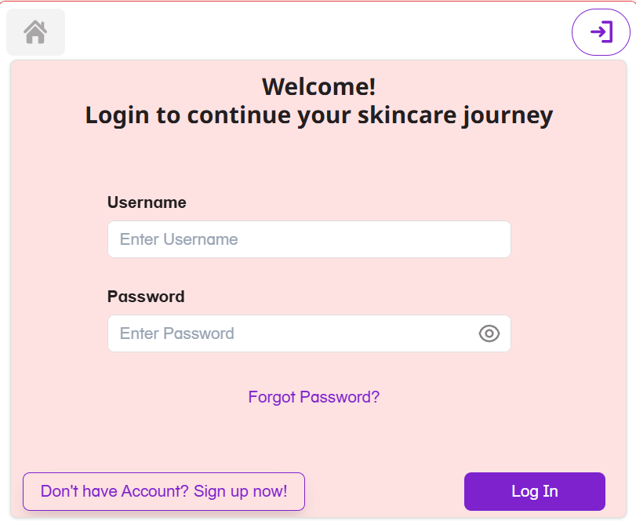

Figure 2: Screenshot of explore and filter product page

A screenshot of a product

Figure 2: Screenshot of explore and filter product page

Figure 3: Personalized Quiz Page for customizing skincare routine using Machine Learning/AI

Figure 4: Screenshot of Home Page

GitHub Link: <https://github.com/chenj926/skinMatch>

Appsmith Web Application: <https://app.appsmith.com/app/skincare-app/group-and-search-products-page-679e45465cf4523a71bcdce9?branch=master>